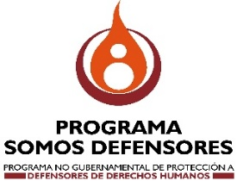

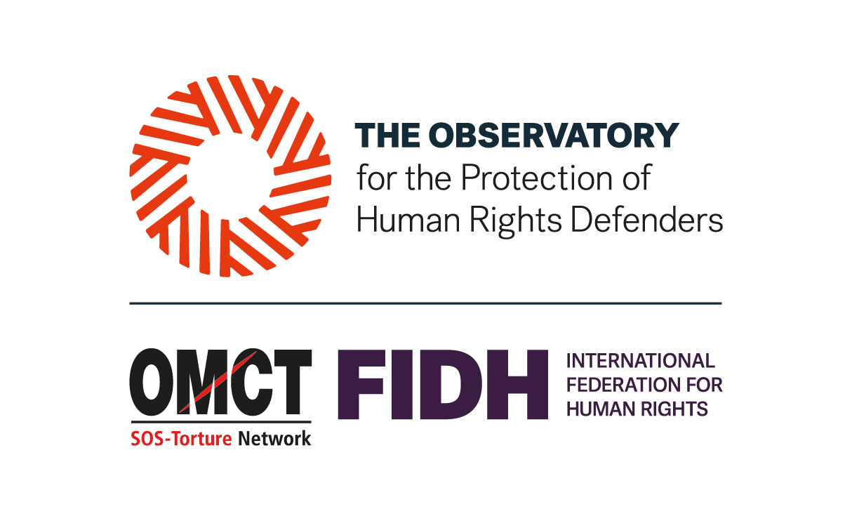


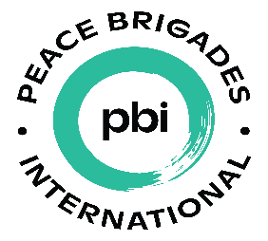


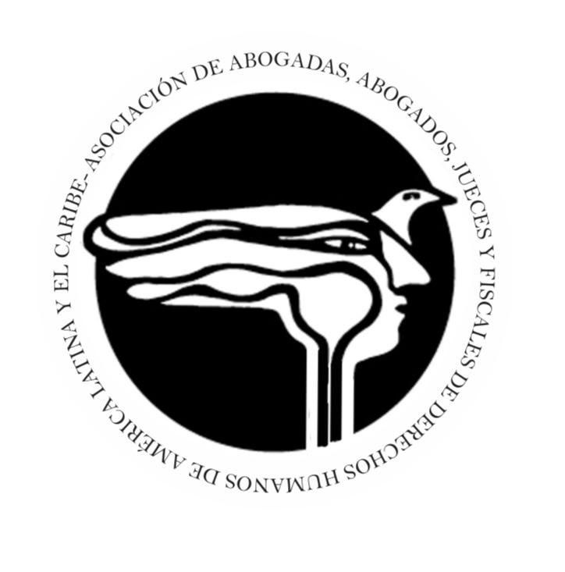
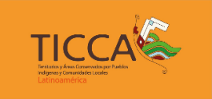

Ecuador: International organisations alert of the rapid deterioration of the human rights situation

- As part of a human rights observation visit, the organisations visited several communities and interviewed human rights and environmental defenders, civil society organisations, public institutions and the international community.
- The information gathered points to the closure of civic space, criminalisation and increased threats against human rights defenders, especially in contexts of extractivism or socio-environmental conflicts, threats to judicial independence and a security policy based on the militarisation of the state's response to human rights issues.
Quito, 6 March 2026. International human rights organisations conducted an observation visit to Ecuador from 2 to 5 March 2026, due to growing concern about the deteriorating human rights situation in the country and the difficulties in exercising the defence of these rights, including access to public information.
During the visit, our organisations held meetings with communities, human rights and environmental defenders, civil society representatives, authorities, international organisations and representatives of the international community in order to obtain a comprehensive and verified overview of the current situation.
Based on the information obtained, our organisations unanimously express our grave concern about the situation of repression and human rights violations, particularly against human rights defenders as well as Indigenous Peoples and Nationalities, “campesino” and Afro-descendant communities, women and young people, and civil society organisations that make up the social fabric of Ecuador.
Against this deeply worrying backdrop, we would like to draw attention to the following issues:
- The rapid deterioration of civic space, including the stigmatisation and criminalisation of human rights and environmental defenders, the use of SLAPPs (strategic lawsuits against public participation) and the violent repression of peaceful protests led by indigenous movements in the context of states of emergency, and the rapid implementation of a new regulatory framework and arbitrary practices against civil society organisations.
- The implementation of a securitised policy and the normalisation of states of emergency, surveillance and militarisation under the pretext of addressing a serious structural security crisis, as well as the erosion of judicial independence and the rule of law.
- The adoption of an extractivist approach without prior consultation in the context of the implementation of projects, nor respect for the will of the people expressed in other mechanisms of direct participation. This has had serious impacts on collective rights and the rights of nature, undermining fundamental democratic freedoms.
- The findings and recommendations will be consolidated in a joint report to be published in the coming months. The organisations participating in the visit will continue to accompany, monitor and raise awareness internationally about the situation of human rights and the rights of nature in Ecuador.
Preliminarily, the organisations call for:
- The Ecuadorian State must guarantee the rights enshrined in the Constitution, comply with the recommendations issued by intergovernmental human rights organisations, and fulfil the obligations it has undertaken through the international treaties it has ratified.
- The international community must reinforce its monitoring of the situation of human rights and environmental defenders, provide assistance to strengthen the rights system, and offer direct support to civil society as a whole.
Finally, our organisations express our solidarity and recognise the dignity and determination of those who continue to legitimately defend their rights in an increasingly hostile environment.

Organisations participating in the visit
- 11.11.11
- Asociación de Abogadas, Abogados, Jueces y Fiscales de Derechos Humanos de América Latina y el Caribe (AJUFIDH)
- Peace Brigades International
- CIVICUS: World Alliance For Citizen Participation
- Red Territorios de Vida TICCA Latinoamérica
- International Federation for Human Rights (FIDH), in the framework of the Observatory for the Protection of Human Rights Defenders
- Front Line Defenders (FLD)
- World Organisation Against Torture (OMCT), in the framework of the Observatory for the Protection of Human Rights Defenders
- Programa Somos Defensores
- World Rainforest Movement (WRM)

-END-

