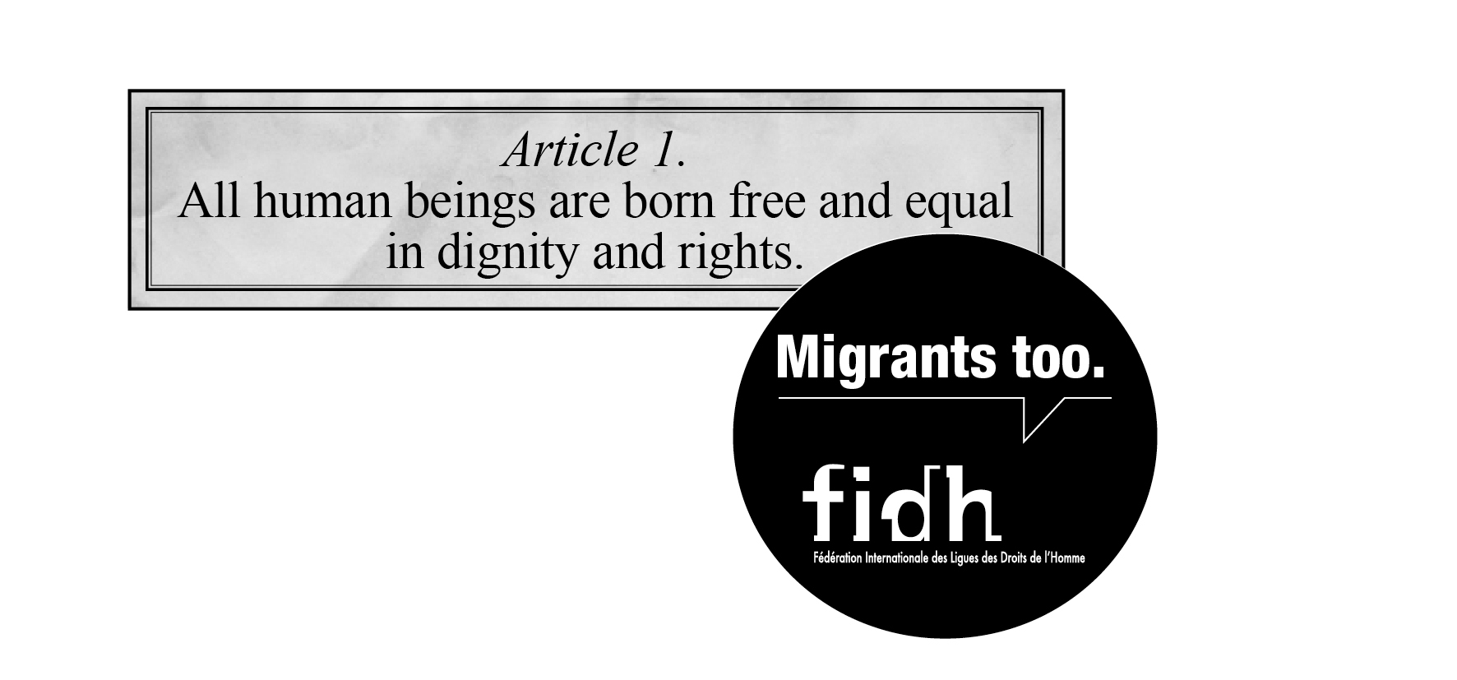

20th Anniversary of the United Nations Convention on Migrants' Rights :
Call for ratification by [State]

Open Letter to [Head of State, Country]

[Place, date]

Your Excellency,

As we enter the 20th anniversary year of the International Convention on the Protection of the Rights of All Migrant Workers and Members of Their Families (ICRMW), a global campaign has been launched calling on governments to act immediately to end the widespread violations of human rights suffered daily by migrants around the world by ratifying this Convention.

As yet, [country] has not ratified this core United Nations instrument. Today, we are writing to call upon your government to do so, thereby demonstrating your commitment to ending abuse of migrants by protecting their human rights.

More than 200 million persons across the world are migrants, representing nearly 3% of the world population. All countries are affected by migration either as origin, destination or transit countries and all states are thus confronted with the challenges of developing effective migration policies with human rights at their core.

Although, for many, migration is a positive experience, many others migrate under duress and face severe hardships in their countries of destination. Migrant workers all over the world remain particular targets of abuse, discrimination and exploitation by traffickers, smugglers and employers. Yet an instrument is at your government's disposal to minimise this and to strengthen their legal protection.

The ICRMW recognises the specific vulnerabilities of migrant workers and promotes humane and lawful working and living conditions and the need for increased protection. It provides guidance on the elaboration of migration policies, which can only be effective if they are based on legal standards and the rule of law. This Convention is thus a vital part of efforts to combat exploitation of migrant workers and members of their families.

Since its adoption by the United Nations General Assembly in 1990, the ICRMW has been ratified by 42 states. However, in order to become an effective instrument for fighting violations of migrants' human rights, all states, those of departure, transit and destination of migrants, must ratify.

We therefore urge the Government of [country] to seize this occasion to ratify the ICRMW and to lead by example and to demonstrate true commitment to universal human rights by recognising the fundamental human rights of migrant workers. We strongly hope that on the occasion of the 20th anniversary of the Convention, on 18 December 2010, we can also celebrate its ratification by [country].

We would be very interested to receive your Government’s views on the matters raised in this letter and look forward to hearing from you.

Yours sincerely,

Name of organisation/ individual

The campaign is launched by the International Steering Committee for the Campaign for Ratification of the Migrants Rights Convention, a unique network of UN agencies, international organizations and global civil society organizations. For more information visit: http://www.fidh.org/-Migrants-Rights-

